**Initial Model Training Code, Model Validation and Evaluation Report**

**Project Name:** COVID-19 Chest X-Ray Image Classification

### **Data Split**

* Training set: 80% of images (from train folder)
* Validation set: 20% of images (subset of train using ImageDataGenerator)
* Testing set: Separate test folder used for unbiased evaluation

### **Models Trained**

CNN approache were explored:

* **Model 1:** Pretrained **VGG16** (transfer learning) with custom dense layers for classification.

**Initial Model Training Code :**

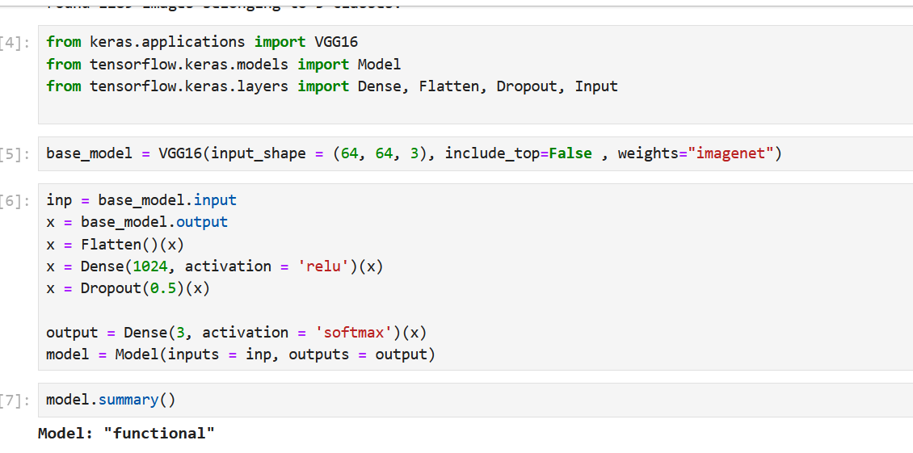

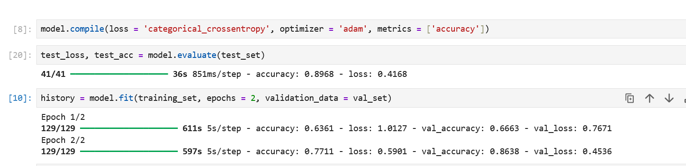

**Model Validation and Evaluation Report :**

| **Model** | **Summary** | **Training and Validation Metrics** |
| --- | --- | --- |
| Model - A : VGG - 16 | Achieved high accuracy by leveraging pretrained ImageNet weights. Fine-tuned dense layers to adapt to chest X-ray dataset. |  |